GitHub Docs

Definition
# Source: ScreenShots Source: Provided by: [Persons Table -> ID Column: 1, Name_En Column: Motasem Essam] -> Tool: [Lightshot Program] -> From [Site: https://docs.github.com/] on [2/15/2026]
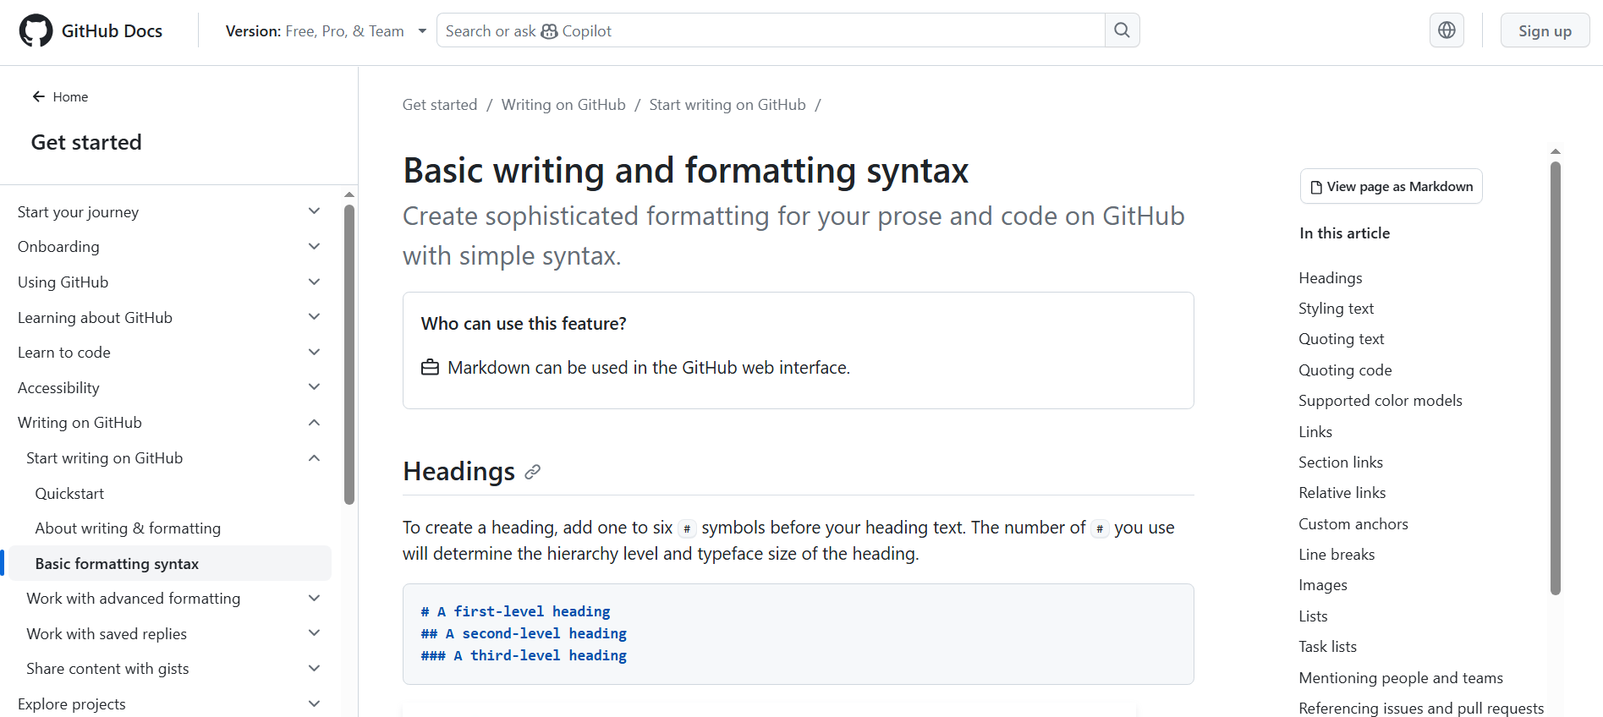
# Source: AI Source: Provided by: [Data Path: Persons Table -> ID Column: 1, Name_En Column: Motasem Essam] -> From: [ChatGPT] on [2/15/2026]
The GitHub Docs site is the official documentation website for GitHub. It provides guides, tutorials, and reference materials to help you learn and use GitHub’s features.

What you can find there
# Source: AI Source: Provided by: [Data Path: Persons Table -> ID Column: 1, Name_En Column: Motasem Essam] -> From: [ChatGPT] on [2/15/2026]
- Getting started with GitHub (accounts, repositories, commits, etc.)
- GitHub Actions (automation & CI/CD)
- GitHub Pages (hosting websites)
- Security & permissions
- Git and version control basics
- API and developer guides
- Troubleshooting and best practices
In short, it’s the main place to learn how to use GitHub—from beginner to advanced level.

Purpose of GitHub Docs
# Source: AI Source: Provided by: [Data Path: Persons Table -> ID Column: 1, Name_En Column: Motasem Essam] -> From: [ChatGPT] on [2/15/2026]
The GitHub Docs site is meant to teach users how to use GitHub effectively. It’s the official reference for developers, teams, and organizations to:
- Understand Git concepts (commits, branches, merges).
- Learn GitHub-specific workflows (pull requests, issues, projects).
- Use GitHub tools like Actions, Packages, and Pages.
- Access API documentation for automation and integration.

Structure of the Docs
# Source: AI Source: Provided by: [Data Path: Persons Table -> ID Column: 1, Name_En Column: Motasem Essam] -> From: [ChatGPT] on [2/15/2026]
The site is organized into sections for easier navigation:
- Get started – Basics like creating accounts, repositories, and understanding commits.
- Guides and tutorials – Step-by-step instructions for common tasks.
- Reference materials – Detailed documentation of commands, API endpoints, configuration options.
- Advanced features – GitHub Actions, security, CI/CD, GitHub Pages, code scanning, and automation.
- Enterprise & admin – Features for organizations, teams, and repository management.

Key Features
# Source: AI Source: Provided by: [Data Path: Persons Table -> ID Column: 1, Name_En Column: Motasem Essam] -> From: [ChatGPT] on [2/15/2026]
- Searchable content – Quickly find topics or commands.
- Code snippets – Copy-and-paste ready examples.
- Versioned docs – Some sections show differences between GitHub Free, Pro, and Enterprise.
- Multilingual support – Some content available in languages other than English.

Why it’s useful
# Source: AI Source: Provided by: [Data Path: Persons Table -> ID Column: 1, Name_En Column: Motasem Essam] -> From: [ChatGPT] on [2/15/2026]
Even if you’re a beginner, GitHub Docs helps you:
- Learn GitHub workflows step by step.
- Solve errors or troubleshoot issues.
- Automate tasks using GitHub Actions or APIs.
- Understand security best practices for repositories and organizations.

Basically, it’s like the user manual, tutorial library, and reference guide all in one for GitHub.

